**DATA SCIENCE LAB**

**EXPERIMENT -1**

**AIM: Write a pythom program that takes an input n and calculate n+nn+nnn**

**Program**

n = input("Enter an integer: ")

n1 = int(f"{n}")

n2 = int(f"{n}{n}")

n3 = int(f"{n}{n}{n}")

n4 = n1 + n2 + n3

print(n1)

print(n2)

print(n3)

print(f"Computed value of {n1}+{n2}+{n3} = {n4} ")

**Output**

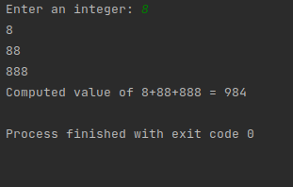

**EXPERIMENT -2**

**AIM:Write a python program to get a largest number from a list**

**Program**

list1 = [10, 20, 40, 45, 100]

# printing the maximum element

print("Largest element is:", max(list1))

**Output**

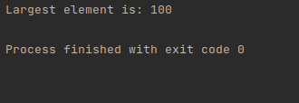

**EXPERIMENT -3**

**AIM: Write a python program to clone or copy a list.**

**Program**

# Using the in-built function list()

def Cloning(li1):

li_copy = list(li1)

return li_copy

li1 = [4, 8, 2, 10, 15, 18]

li2 = Cloning(li1)

print("Original List:", li1)

print("After Cloning:", li2)

**Output**

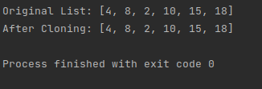

**EXPERIMENT -4**

**AIM: Write a python program to shuffle and print a specified list.**

**Program**

import random

number_list = [7, 14, 21, 28, 35, 42, 49, 56, 63, 70]

print ("Original list : ", number_list)

#shuffle method

random.shuffle(number_list)

print ("List after shuffle : ", number_list)

**Output**

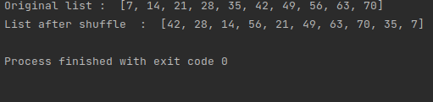

**EXPERIMENT -5**

**AIM: Write a python program script to sort a python dictionary by value.**

**Program**

import operator

d = {1: 2, 3: 4, 4: 3, 2: 1, 0: 0}

s = sorted(d.items(), key=operator.itemgetter(1))

print('ascending order : ', s)

s1 = dict(sorted(d.items(), key=operator.itemgetter(1), reverse=True))

print('descending order : ', s1)

**Output**

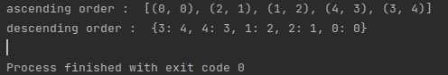

**EXPERIMENT -6**

**AIM: Write a python program script to add key to a dictionary.**

**Program**

dict = {'Name':'Tom', 'Roll no':20}

print(dict)

dict.update({'Name':'Ammu', 'Roll no':15})

print(dict)

**Output**

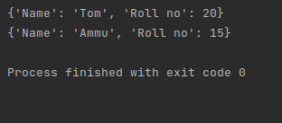

**EXPERIMENT -7**

**AIM: Write a python program script to merge two dictionaries.**

**Program**

def Merge(dict1, dict2):

return (dict2.update(dict1))

dict1 = {'a': 10, 'b': 20}

dict2 = {'c': 30, 'd': 40}

print(Merge(dict1, dict2))

print(dict2)

**Output**

